
Name: Janushiya P A
Reg No: 1924260368
Course Code: CSA0224
Course Name: C Programming

TASK 2 – CHOOSE THE DATA TYPES
Bloom’s Level: K4 – Analyse

1. Aim
To select suitable C data types for an electricity billing system and calculate meter consumption correctly, including meter register rollover.

2. Data Type Table
Data item | Data type | Size (typical) | Range / purpose
Meter reading | unsigned short | 2 bytes | 0 to 65,535
Units consumed | unsigned int | 4 bytes | Non-negative consumption
Consumer count | unsigned int | 4 bytes | Stores consumer numbers
Money in paise | long long | 8 bytes | Exact integer money storage
Decimal calculation | double | 8 bytes | Approximate floating-point values
Sizes and ranges depend on the compiler and system. sizeof checks the size, limits.h provides integer limits, and float.h provides floating-point limits.
Why integer paise? Floating-point values cannot represent all decimal amounts exactly. For 4,000 bills of ₹0.10, float accumulation can give approximately ₹400.015 instead of ₹400.00. Storing 10 paise per bill gives exactly 40,000 paise = ₹400.00, provided no integer overflow occurs.

3. Algorithm
- Start.
- Read the previous and current meter readings.
- Subtract the previous reading from the current reading using unsigned 16-bit arithmetic.
- Print the consumption.
- Stop.

4. Code

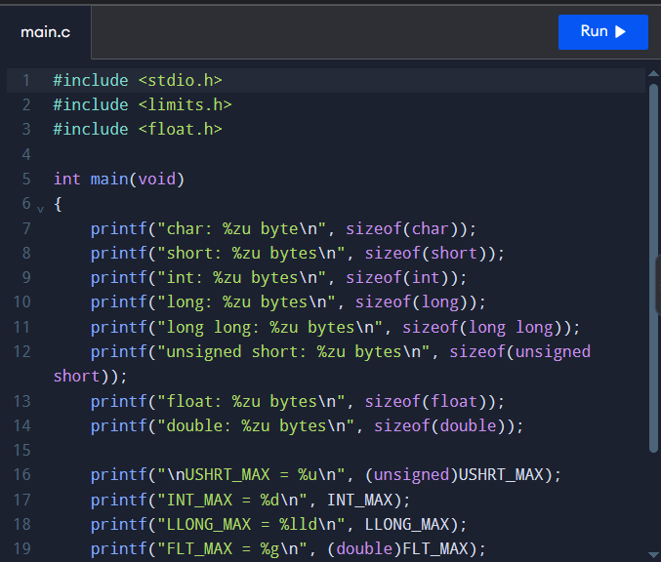

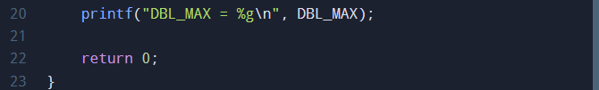

6. Output

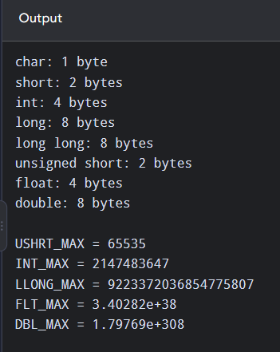

7. Explanation
A 16-bit unsigned register stores values from 0 to 65,535. After 65,535, it rolls over to 0.
For the second test:
Consumption = (65,536 − 65,400) + 120 = 256 units.
The result is positive because unsigned 16-bit arithmetic wraps modulo 65,536.

8. Complexity Analysis
- Time per addition: O(1) for both integer paisa and double.
- Total time for n bills: O(n).
- Extra space for a running total: O(1).
- Integer paise avoid rounding errors in addition, while double may accumulate small floating-point errors. Both typically occupy 8 bytes for long long and double, respectively.
If money is stored as double rupees, rounding to two decimal places is normally applied when converting the final total to a displayed bill amount.

9. Result
Suitable C data types were selected, and the program successfully calculated normal meter consumption and rollover consumption. Integer paise were identified as the preferred method for accurate money calculations.

